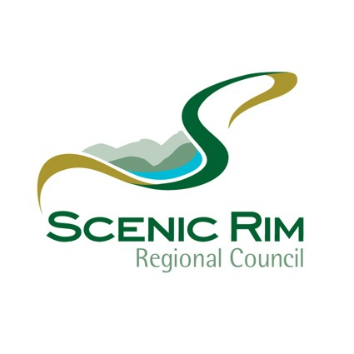

Community Grants Program and
Sport and Active Recreation Grants Program

Project Report and Acquittal Form

Please Note:

- Within two (2) months of funds being expended, grant recipients must complete and return to Council the grant acquittal form.
- The Project Report & Acquittal Form is to be returned to The Chief Executive Officer, Scenic Rim Regional Council, PO Box 25, Beaudesert, Qld 4285.
- Or email to mail@scenicrim.qld.gov.au

Section A – Organisation Details

- Name and Address of your Organisation.

- Address for Correspondence (if different to above).

- Contact Person’s Name.

- Contact Details.

Phone |  |  | Fax
Mobile |  |  | Email

Section B – Financial Details

To fully acquit the funded project your organisation must prove it has expended the eligible project cost on eligible items of expenditure as outlined in the Community and Sport & Active Recreation Guidelines. If the project has been completed under budget or your organisation has spent the grant funds on ineligible items then your organisation will be requested to return the unexpended funds or repay the amount spent on ineligible items.

The expenditure on the project should be supported by one of the following:

- Receipts and invoices for each item of expenditure listed in the ‘Grant Expenditure Statement’ should be attached. Bank statements and delivery dockets are not acceptable; or
- An original auditor’s certification complete with the telephone number and qualifications of the auditor certifying that he/she has examined the financial records as detailed in the ‘Grant Expenditure Statement’ and certification that the expenditure is in accordance with the grant payment.

Grant Approval Amount Received from Council: $

ABN …………………………………………….. GST Registered? Yes No
Grant Expenditure Statement (List of Receipts and Invoices)

Please list the details of all receipts and invoices related to this claim in the following table. Items claimed must be only those deemed eligible according to your original application and as outlined in the Community and Sport and Active Recreation Grants Program Guidelines.

Please attach all documentation to support the following.

Receipt/Invoice No. | Total Amount of Receipt/Invoice | GST Amount | Receipt/Invoice Value Excluding GST | Provider of Goods/Services | Goods/Services Provided

Sub Total
Grant Approval Amount
Variance

Section C – Project Report

- Brief project description.

- Describe how Scenic Rim Regional Council was acknowledged for the support it provided. (Please attach any printed material such as signage, press, newspaper clippings, posters etc to this form).

- Please provide a summary of how the project was implemented and what it achieved.
Please include answers to the following questions:
  - What was the aim of the grant funding?
  - How do you know you achieved that aim?
  - Who benefited from the project?

Section D – Claimant’s Declaration

Please have two members of your organisation sign the declaration below. Only the Chairperson, or President (or another officer, formally delegated such authority *), and the Secretary/Treasurer of the organisation which is to receive the grant should sign.

We certify that the total amount of this acquittal relates to funding approved in the project report as identified in Section B of this acquittal form.

Name |  |  | Name
Position |  |  | Position
Signature |  |  | Signature
Date |  |  | Date

PLEASE NOTE: * Where this agreement is signed by a delegated officer, current documentation authorising such a delegation of authority signed by the Chairperson or President, must be attached to this agreement.

