Scenic Rim Planning Scheme Code Template
  - 8.2.2 Airport Environs and Defence Land Overlay Code
8.2.2.1Application

This code applies to development:
- within the Airport Environs and Defence Land Overlay as identified on the overlay maps contained in Schedule 2 Mapping; and
- identified as requiring assessment against the Airport Environs and Defence Land Overlay Code by the tables of assessment in Part 5 Tables of Assessment.

8.2.2.2Purpose and Overall Outcomes

- The purpose of the Airport Environs and Defence Land Overlay Code is to ensure that development does not compromise aircraft safety of strategic airports, the efficient functioning of aviation facilities or the continued viability of defence land.

- The purpose of the code will be achieved through the following overall outcomes:
- Development does not create incompatible intrusions or compromise aircraft safety in the operational airspace (Height Restriction Zones and Wildlife Buffer Areas) of strategic airports;
- Development in Building Restricted Areas, does not adversely affect the functioning of aviation facilities; and
- Development in the Defence Land Buffer Area:
- does not result in uses incompatible with the defence land;
- is designed and sited to not adversely affect the safety and operational efficiency of defence operations; and
- attenuates noise from defence operations

8.2.2.3 Assessment Benchmarks

Table 8.2.2.3.2— Airport Environs and Defence Land Overlay Code - for Accepted and Assessable Development
Performance Outcomes | Acceptable Outcomes | Applicant Comments | Assessment Officer
Height Restriction Zone
PO1  Development located in a Height Restriction Zone does not create a permanent or temporary physical or transient obstruction in an operational airspace. | AO1.1  Sport and recreational aviation activities including parachuting, hot air ballooning and hang-gliding do not occur within a Height Restriction Zone.
AO1.2
The height of buildings, structures and mature landscaping is no greater than 45m (above natural ground level) in Height Restriction Zone A and 90m (above natural ground level) in Height Restriction Zone B.

AO1.3
Cranes and other equipment used during construction are of a height no greater than 45m in Height Restriction Zone A and 90m in Height Restriction Zone B.

Editor's note - Encroachments of a height greater than 45m in Height Restriction Zone A and 90m in Height Restriction Zone B must be referred to the Department of Defence (DoD) for assessment.

PO2  The emissions from the development do not significantly increase air turbulence, reduce visibility or compromise the operation of aircraft engines in a Height Restriction Zone. | AO2.1  Development does not emit smoke, dust, ash or steam into a Height Restriction Zone.
AO2.2
Development does not emit a gaseous plume into a Height Restriction Zone at a velocity exceeding 4.3m per second.
AO2.3
Development emitting smoke, dust, ash, steam or a gaseous plume exceeding 4.3 metres per second is designed and constructed to mitigate adverse impacts of emissions within a Height Restriction Zone.

Editor's note - Proposals with the potential to affect visibility in a Height Restriction Zone must be referred to the Department of Defence (DoD) for assessment.

Wildlife Buffer Area
PO3  Development does not cause wildlife to create a safety hazard within a strategic airport's operational airspace. | AO3  A land use listed in Table 8.2.2.3.4 - Land Uses That Can Attract Wildlife (which are associated with increases in wildlife strikes and hazards) and located in the Wildlife Buffer Area does not increase the potential to attract birds and bats.  Table 8.2.2.3.4- Land Uses That Can Attract Wildlife  High Risk Activities Moderate Risk Activities  Rural- - Cropping (turf farm); - Cropping (fruit tree farm); - Intensive animal industry (piggery); - Aquaculture (fish processing/packing plant). Rural- - Animal husbandry; (cattle/dairy farm); - Intensive animal industry (poultry farm).  Conservation- - Conservation estate (eg. wetland). Conservation- - Conservation estate (all other).  Recreation- - Major sport, recreation and entertainment facility (showground). Recreation- - Major sport, recreation and entertainment facility (all other); - Outdoor sport and recreation; - Park.  Industry- - Low impact industry (food processing plant); - Medium impact industry (food processing plant); - High impact industry (food processing plant). Recreation- - Major, sport, recreation and entertainment facility (all other).  Utility installation- - Food/organic waste facility; - Putrescible waste facility (e.g. landfill, transfer station). Utility installation- - Non-putrescible waste facility (e.g. landfill, transfer station); - Sewerage/wastewater treatment facility.  Editor's note - Proposals involving the above land uses must be referred to the Department of Defence (DoD) for assessment.
Building Restricted Area
PO4  Development does not interfere with the function of aviation facilities. | AO4  Development is not located within:  - 60m of the Non-Directional Beacon (NDB) antenna; or  - 300m from the NDB antenna and the development will cross the zone boundary (zone boundary is defined as an elevation angle of 5 degrees from ground level at the centre of the NDB antenna).  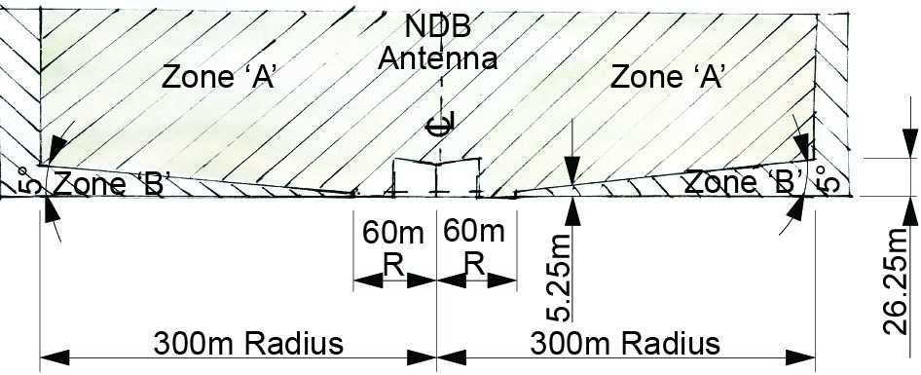  Figure 1 Non directional beacon (NDB)  Note - Refer to Figure 1 Non directional beacon (NDB) for assistance in determining points (a) and (b) above. Any development in the area shown as Zone 'A' on Figure 1 Non directional beacon (NDB) does not meet the outcomes and will elevated to Code Assessment.

Table 8.2.2.3.3— Airport Environs and Defence Land Overlay Code - for Assessable Development
Performance Outcomes | Acceptable Outcomes | Applicant Comments | Assessment Officer
Height Restriction Zone
PO1  - Development located within the Building Restricted Area for an aviation facility does not create:  - permanent or temporary physical obstructions in the line of sight between antennas; or  - an electrical or electromagnetic field that will interfere with signals transmitted by the facility; or  - reflective surfaces that could deflect or interfere with signals transmitted by the facility.  OR  - Development located within the Building Restricted Area for an aviation facility is designed and constructed to mitigate adverse impacts on the function of the facility.  Editor's note - The SPP State Interest Guideline - Strategic Airports and Aviation Facilities provides guidance on development requirements in Building Restricted Areas for aviation facilities.  Editor's note - A development proposal on land located within a Building Restricted Area must be referred to Airservices Australia or the Department of Defence (DoD) for assessment. Airservices Australia or DoD will provide local government and proponents with authoritative advice about the impact of a proposed development on the function of an aviation facility, requirements for a risk assessment process, and mitigation methods. It is recommended that advice be sought during pre-lodgement stage of development assessment processes to avoid objections from Airservices Australia or DoD. | AO1  No acceptable outcome is prescribed.
Defence Land Buffer Area
PO2  Development within the Defence Land Buffer identified on Airport Environs and Defence Land Overlay Map OM-02 does not:  - restrict the nature or scope of defence operations; or  - increase the number of persons living or congregating in the Defence Land Buffer Area. | AO2  Development within the Defence Land Buffer Area does not include any of the following:  - Animal keeping;  - Child care centre;  - Community care centre;  - Community residence;  - Community use;  - Educational establishment;  - Function facility;  - Health care service;  - Home based business (involving Bed and Breakfast);  - Hospital;  - Hotel;  - Multiple dwellings;  - Place of worship;  - Relocatable home park;  - Residential care facility;  - Retirement facility;  - Rooming accommodation;  - Short-term accommodation;  - Tourist park;  - Veterinary service;  - Reconfiguring a lot that results the creation of additional lots.
PO4  Development located in the Defence Land Buffer Area is designed and sited to prevent unintended or unauthorised access to defence land. | AO4  No acceptable outcome is prescribed.
PO5  Development is designed and sited to manage potential noise exposure from the Canungra Land Warfare Centre (identified as Defence Land on Airport Environs and Defence Land Overlay Map OM-02). | AO5  No acceptable outcome is prescribed.

