

**Paper Plate Whale**

**What you need:**

**1.** 1 Paper plate

**2.** Blue paint or crayon

**3.** Black texta and goggle eye

**4.** Blue paper

**5**. Scissors and Glue

**How to:**

Paint or colour the paper plate and let dry.

When it is dry cut a piece from the bottom of the plate, as per picture.

Draw and cut out the shapes for the water spout and tale from the blue paper as shown. Glue these to the paper plate as shown

Add google eye or draw the eye in and add a big whale smile.

Your paper pate whale is done. It's great for an underwater theme.

Also colour in the W for Whale picture.

Fun fact about Whales - Whales can hold their breath for at least 20 minutes

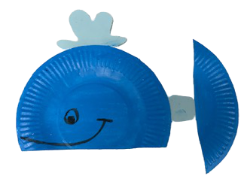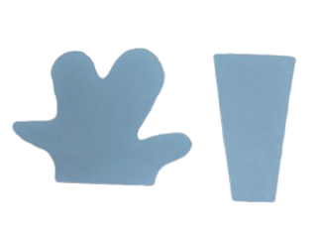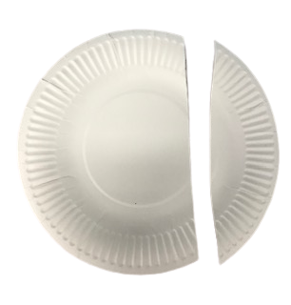under water

