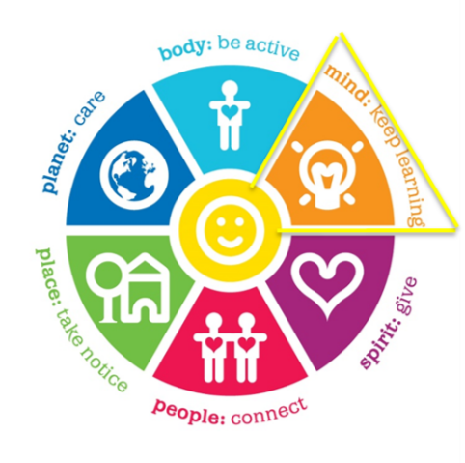

**Seaweed Spaghetti**

This activity is not for the light hearted. It involves letting

Your children play with spaghetti and get messy. It is a fantastic sensory activity that lights up your little ones brains. Sensory activities are great to encourage talking and imaginative play. As they play, talk to your little ones about the animals that might live near the seaweed or in the seaweed etc.

**What you need:**

* 2 to 3 cups of cooked green seaweed spaghetti.
* A big plastic bowl or tub to put the spaghetti in
* Any ocean related toys that you might like to add to your spaghetti as seen in the image below.

**How to:**

**1.** With an adult cook the spaghetti per packet instructions adding some green food dye to your spaghetti as you cook it.

2. Let the spaghetti cool and then put into a tub or big bowl. You can add a bit of olive oil to the spaghetti to make it feel a bit more slippery. Tip* You might like to put your bowl or tub out on the grass or outside as this can get messy.

3. You can add ocean like items to your spaghetti like small toy fish, sharks, whales, or crabs. Or you can add some rocks and stones like below. Let your imagination go wild!

4. Now let your children play with the spaghetti.

